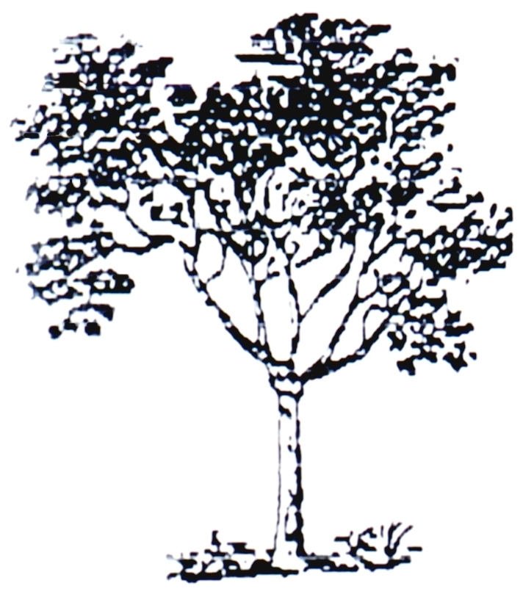

Jimmy Jordan

November 22, 2019

Rest In Peace

